Setting up new clients for edit2021

# Create Local Client Directories

On xampp/htdoc

client_app -- copy all except content from another client & then modify

client_prototype – copy all except content from another client & then modify

# Create Local Database

Copy another client

Erase Content and Members (keep reference databases)

# Create Remote Database

# Create Remote Directories

Client – needs SSL

Client_edit -- – copy all except content from another client & then modify

Client_prototype – needs SSL; – copy all except content from another client & then modify

# VueJS Environmental Variables

Set up both local and remote variables

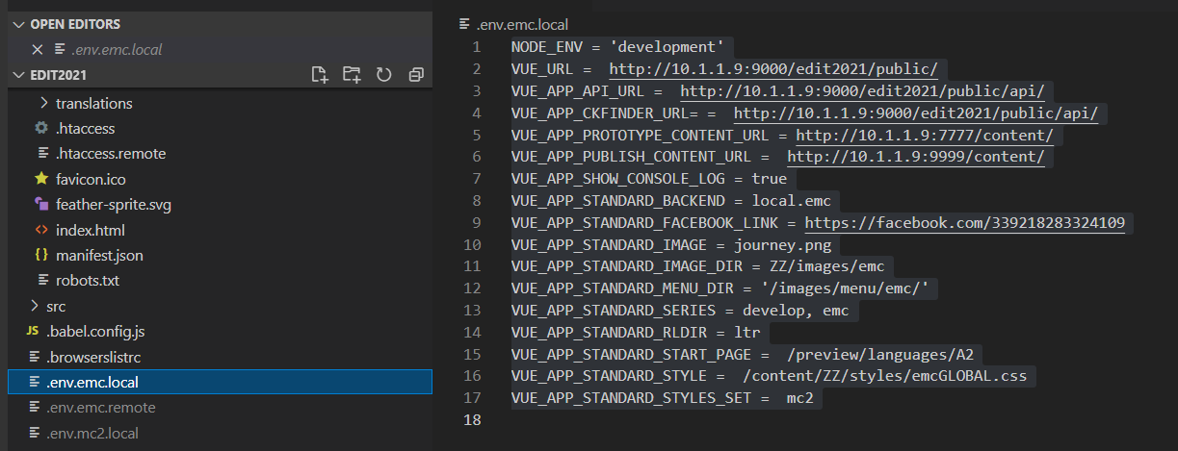

# API Environmental Variables

Set both local and remote .env files

Also make directories for php files unique to this client

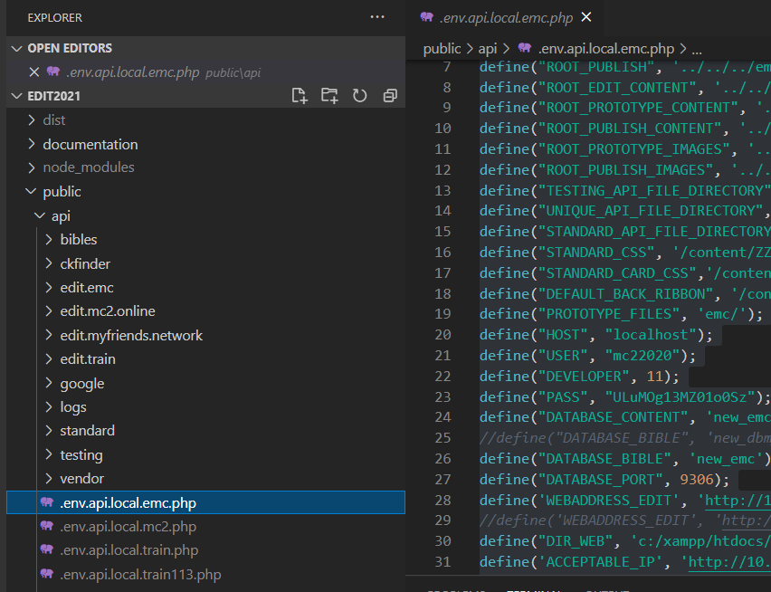

# CKEDITOR

Make any changes to the styles here.

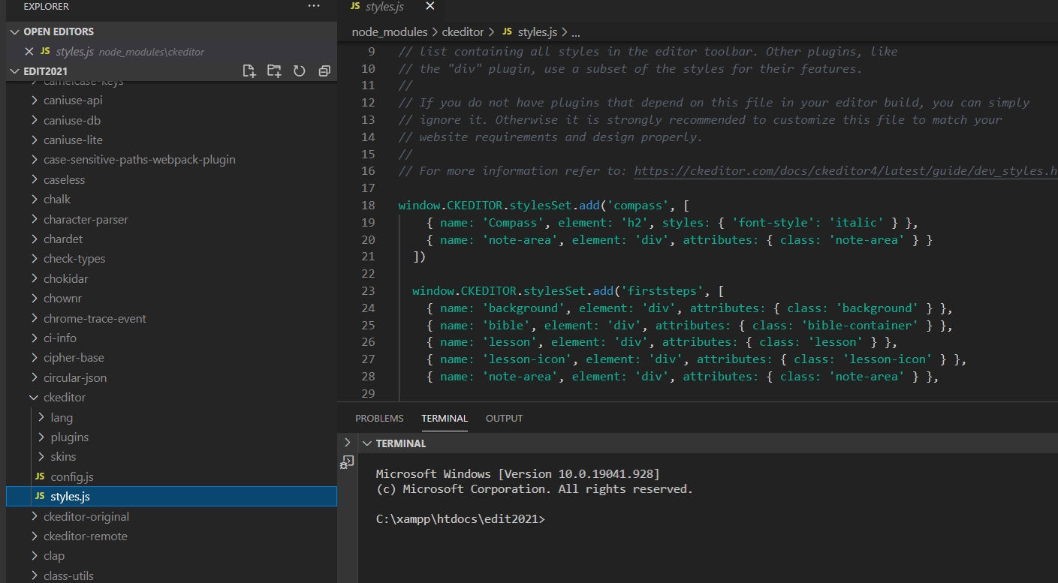

# CKFINDER

You will need to adjust the settings in this file

